Please ensure that the following items have been received and/or completed prior to sending the student their WELCOME EMAIL or admitting them into the classroom. This checklist is to be used for all full qualification courses.

Student Name: Enter Students Name Here

Has the student provided the following items:
A courtesy text message sent to the student
This text message should be sent as soon as we receive the students enrolment form
Check that the enrolment form, ensure that it is signed and dated by the student
Check that we have received an agreed program delivery form, signed and dated by the student
Is the Photo ID clear and easy to read.
At minimum, we need a copy of the students Australian Drivers Licence and Medicare Card. Also check the terms and conditions form to see if the student will be providing a valid concession card
Do we have the student’s enrolment terms and conditions – signed and dated
Has the student provided us with their USI OR do we have enough information to get their USI
Has the student completed their LLN assessment and has this report been downloaded to the students folder.
Have you invited the student to the ITS Student Life Facebook Page?
You can do this by using the ‘Add members’ block within the ITS Student Life Facebook Page.
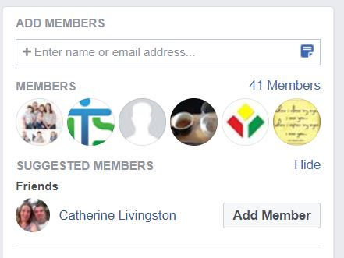
Have you created the students Moodle login details (Username and Password) and enrolled them into the appropriate courses/units.
Have you sent the final text message sent to the student informing them that their enrolment is complete?

Has the following been completed / processed?
Enrolment form been uploaded on the servers (Copied to appropriate folders)
Student invoice been created and sent, includes adding funding information to appropriate documents and setting up direct debit applications
Has the student made first payment?
If the student has supplied us with a valid concession card, have you sent, or arranged the text course text book to be sent to the student?
Standard postage should be used for this process. A listed of the REQUIRED text books will be available on the course information page on the ITS Website
Has a welcome email sent to the student?

Last monitored or updated: 26/06/2018 by SM
OR;
Enrolment completed by: Click or tap here to enter text. on Click or tap to enter a date.

